Suggestions for the following page: <https://www.trgroup.co.nz>

|  |  |
| --- | --- |
| **Browser** | Chrome Version 89.0.4389.114 (64-bit) |
| **Device & Operating System** | Lenovo ThinkPad W541 Windows 10 |
| **Suggestion** | **Video Thumbnails could be smaller so that can fit in one row** |
| **Steps to reproduce** | 1. Open Chrome browser 2. Navigate to <https://www.trgroup.co.nz> 3. Scroll down the page 4. Check the Thumbnail for videos 5. Change the size of Thumbnail videos |

Screenshot:

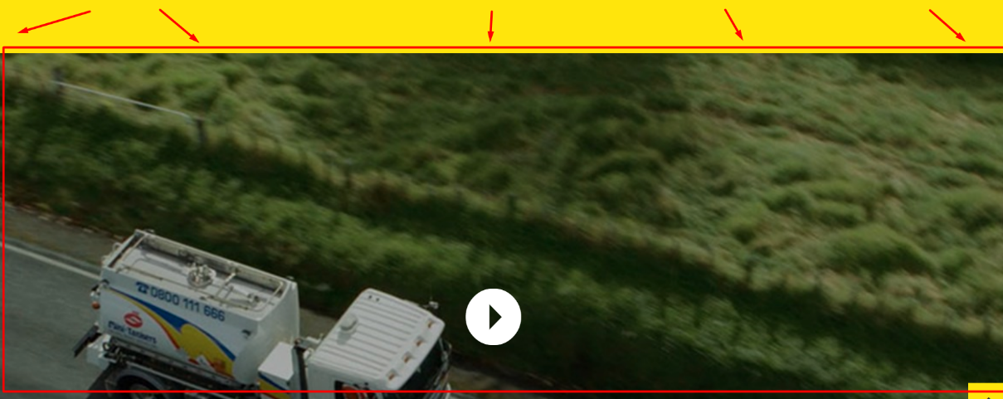

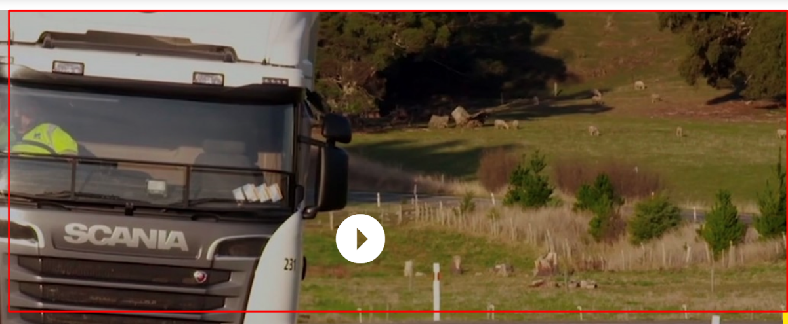

|  |  |
| --- | --- |
| **Browser** | Chrome Version 89.0.4389.114 (64-bit) |
| **Device & Operating System** | Lenovo ThinkPad W541 Windows 10 |
| **Suggestion** | **Empty space on the top corners. Move the logo and name of the site more to the left and search box and button to the right.** |
| **Steps to reproduce** | 1. Open Chrome browser 2. Navigate to <https://www.trgroup.co.nz> 3. Check the empty space in the corners 4. Move the site logo and name to the left 5. Move the search box and button to the right |

Screenshot:



|  |  |
| --- | --- |
| **Browser** | Chrome Version 89.0.4389.114 (64-bit) |
| **Device & Operating System** | Lenovo ThinkPad W541 Windows 10 |
| **Suggestion** | **Empty space on the top. Put the Sing Up “Name” and “email” box from the bottom of the page to the top to fill the empty space.** |
| **Steps to reproduce** | 1. Open Chrome browser 2. Navigate to <https://www.trgroup.co.nz> 3. Check the empty space in the top 4. Move the “Name” box to Sign Up to the top of the page on the empty space 5. Move the “Email” box to the top of the page on the empty space |

Screenshot:

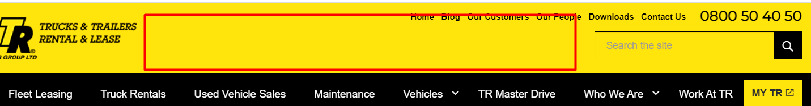

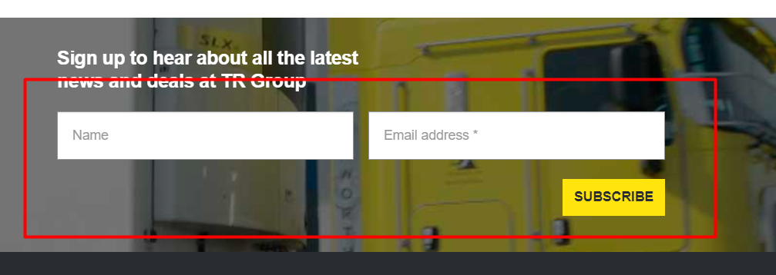

|  |  |
| --- | --- |
| **Browser** | Chrome Version 89.0.4389.114 (64-bit) |
| **Device & Operating System** | Lenovo ThinkPad W541 Windows 10 |
| **Suggestion** | **Put the log in sign or text next to the “MY TR” field to get better functionality.** |
| **Steps to reproduce** | 1. Open Chrome browser 2. Navigate to <https://www.trgroup.co.nz> 3. Check the log in field in the top right 4. Put the Sign in sign next to it |

Screenshot:

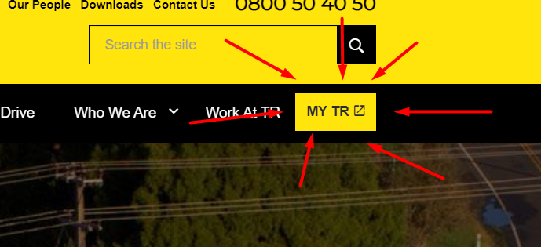

|  |  |
| --- | --- |
| **Browser** | Chrome Version 89.0.4389.114 (64-bit) |
| **Device & Operating System** | Lenovo ThinkPad W541 Windows 10 |
| **Suggestion** | **Make the “Search Rentals” button bigger** |
| **Steps to reproduce** | 1. Open Chrome browser 2. Navigate to <https://www.trgroup.co.nz> 3. Click on the “Truck Rentals” 4. Check the “Search Rentals” button 5. Make the button bigger. It’s too small. |

Screenshot:

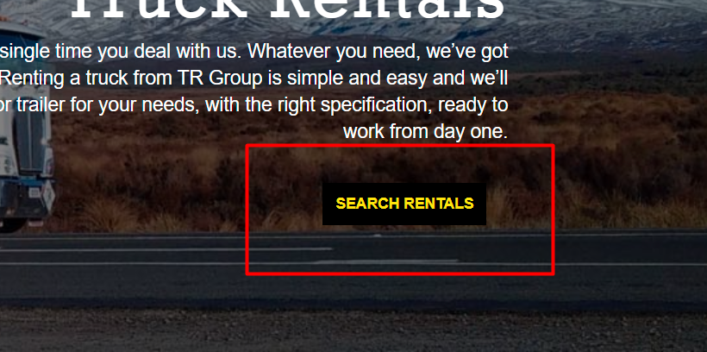

|  |  |
| --- | --- |
| **Browser** | Chrome Version 89.0.4389.114 (64-bit) |
| **Device & Operating System** | Lenovo ThinkPad W541 Windows 10 |
| **Suggestion** | **On the Maintenance page make the font letters size larger.** |
| **Steps to reproduce** | 1. Open Chrome browser 2. Navigate to <https://www.trgroup.co.nz> 3. Click on the “Maintenance” page 4. Scroll down to the “Managed Maintenance” text 5. Make the text larger, it’s very small compared to the image next to it. |

Screenshot:

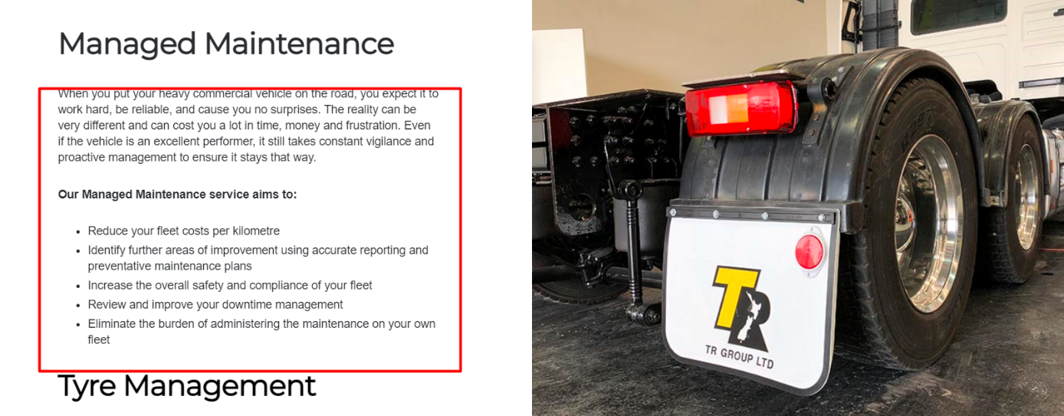

|  |  |
| --- | --- |
| **Browser** | Chrome Version 89.0.4389.114 (64-bit) |
| **Device & Operating System** | Lenovo ThinkPad W541 Windows 10 |
| **Suggestion** | **Change the background color of the dropdown menu in Vehicles page** |
| **Steps to reproduce** | 1. Open Chrome browser 2. Navigate to <https://www.trgroup.co.nz> 3. Click on the Vehicles menu page 4. Check the grey dropdown menu 5. Change the background color to have better visibility |

Screenshot:

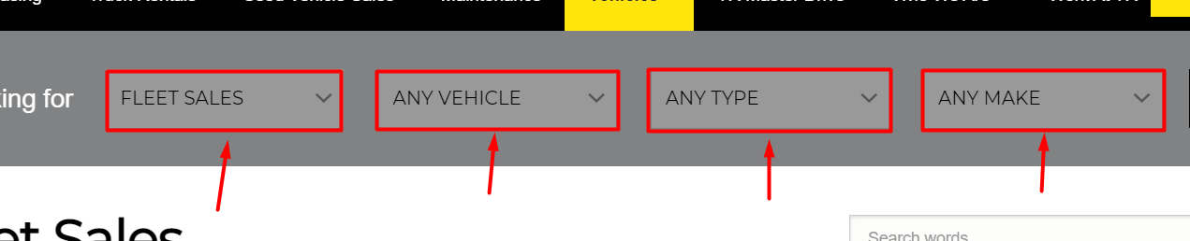

|  |  |
| --- | --- |
| **Browser** | Chrome Version 89.0.4389.114 (64-bit) |
| **Device & Operating System** | Lenovo ThinkPad W541 Windows 10 |
| **Suggestion** | **Make the advertising thumbnails better so that prices can be visible** |
| **Steps to reproduce** | 1. Open Chrome browser 2. Navigate to <https://www.trgroup.co.nz> 3. Click on the Vehicles menu page 4. Scroll down to the advertisement thumbnails 5. Make the advertisements alignment better so that they are not overlapping and prices are visible |

Screenshot:

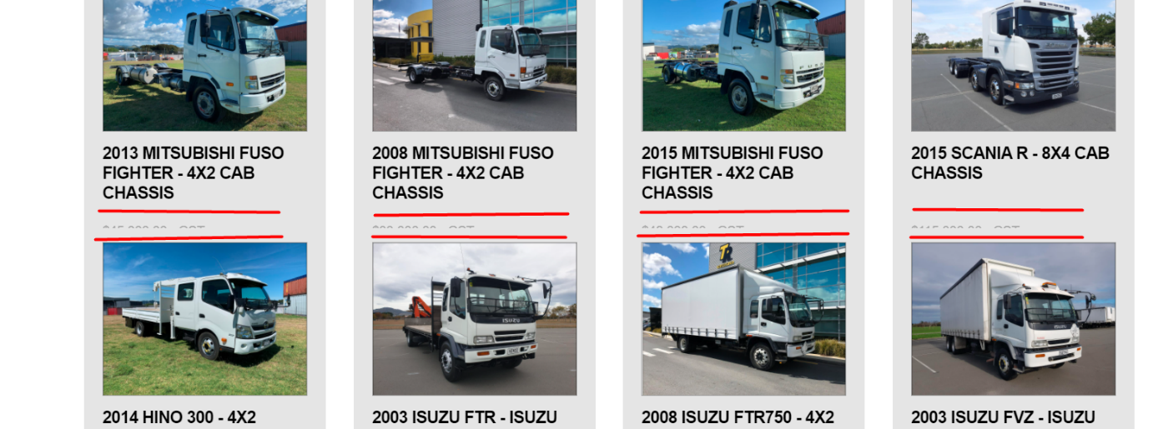

|  |  |
| --- | --- |
| **Browser** | Chrome Version 89.0.4389.114 (64-bit) |
| **Device & Operating System** | Lenovo ThinkPad W541 Windows 10 |
| **Suggestion** | **Change the font color of the prices black so that it has better visibility** |
| **Steps to reproduce** | 1. Open Chrome browser 2. Navigate to <https://www.trgroup.co.nz> 3. Click on the Vehicles menu page 4. Check the vehicle prices 5. Change the color of the prices to black |

Screenshot:

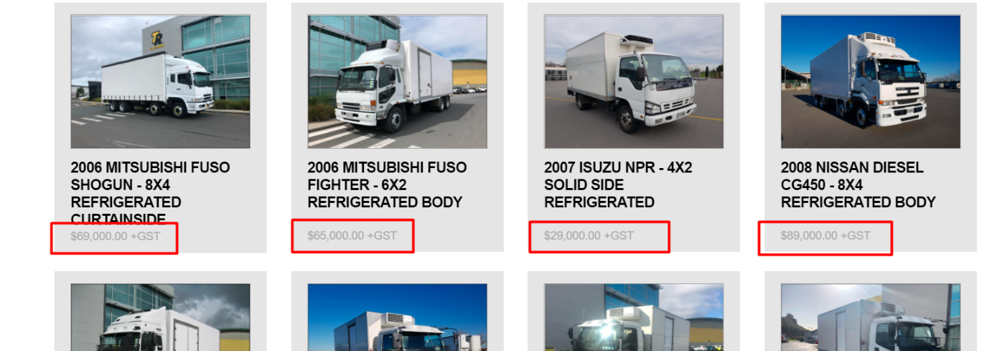

|  |  |
| --- | --- |
| **Browser** | Chrome Version 89.0.4389.114 (64-bit) |
| **Device & Operating System** | Lenovo ThinkPad W541 Windows 10 |
| **Suggestion** | **Put the little eye icon on the password box in the login page so that the user is able to see what symbols are typed** |
| **Steps to reproduce** | 1. Open Chrome browser 2. Navigate to <https://www.trgroup.co.nz> 3. Navigate to login page 4. Put the slam eye icon on the password box and enable to show the typed symbols |

Screenshot:

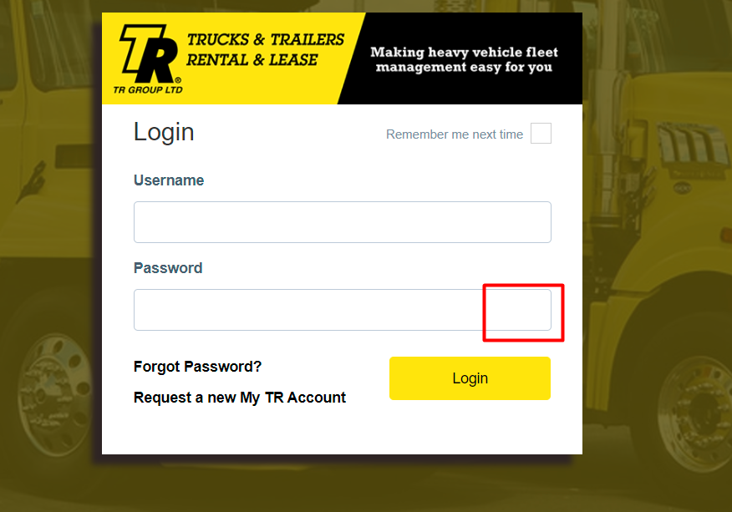

|  |  |
| --- | --- |
| **Browser** | Chrome Version 89.0.4389.114 (64-bit) |
| **Device & Operating System** | Lenovo ThinkPad W541 Windows 10 |
| **Suggestion** | **Separate the two link images on the top of the login page** |
| **Steps to reproduce** | 1. Open Chrome browser 2. Navigate to <https://www.trgroup.co.nz> 3. Navigate to login page 4. Separate the two link images on the top left with a simple black line |

Screenshot:

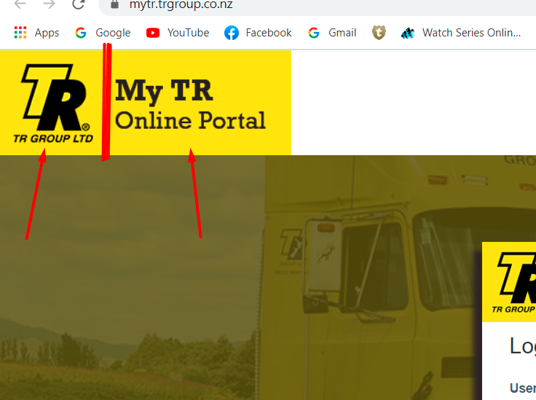

|  |  |
| --- | --- |
| **Browser** | Chrome Version 89.0.4389.114 (64-bit) |
| **Device & Operating System** | Lenovo ThinkPad W541 Windows 10 |
| **Suggestion** | **Add more motivation messages in the “Work At TR” page** |
| **Steps to reproduce** | 1. Open Chrome browser 2. Navigate to <https://www.trgroup.co.nz> 3. Navigate to “Work At TR” page 4. Add some more motivation messages besides repeating only one. With every new image can be new motivation message. |

Screenshot:

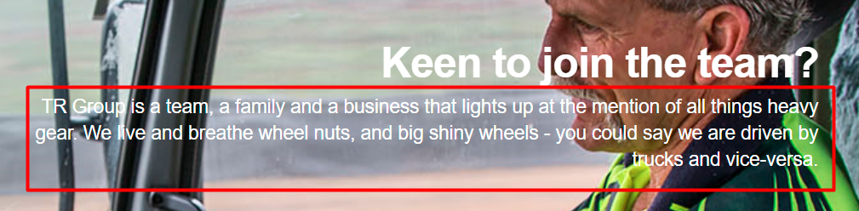

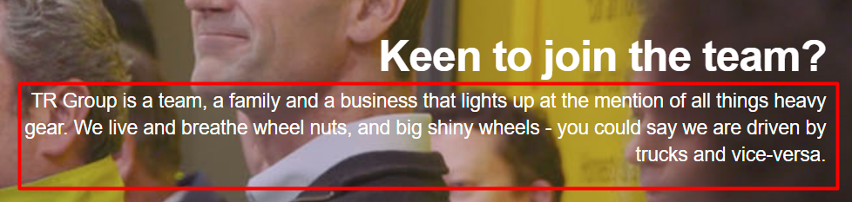

|  |  |
| --- | --- |
| **Browser** | Chrome Version 89.0.4389.114 (64-bit) |
| **Device & Operating System** | Lenovo ThinkPad W541 Windows 10 |
| **Suggestion** | **Change the black and white of the management executive team members to colored on every page.** |
| **Steps to reproduce** | 1. Open Chrome browser 2. Navigate to <https://www.trgroup.co.nz> 3. Scroll down the page 4. Locate the management executive team members. 5. Make the pictures in color on every page, not black and white. |

Screenshot:

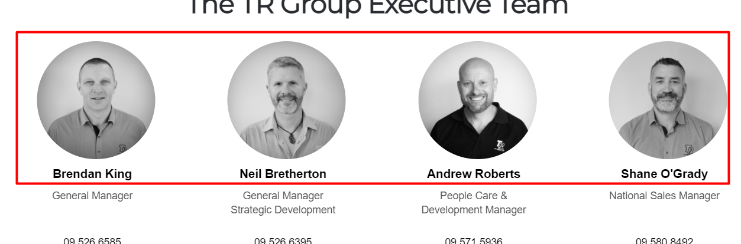

|  |  |
| --- | --- |
| **Browser** | Chrome Version 89.0.4389.114 (64-bit) |
| **Device & Operating System** | Lenovo ThinkPad W541 Windows 10 |
| **Suggestion** | **Fix the spacing of the text links at the bottom of the pages** |
| **Steps to reproduce** | 1. Open Chrome browser 2. Navigate to <https://www.trgroup.co.nz> 3. Scroll to the bottom of the page 4. Fix the spacing of the text links |

Screenshot:

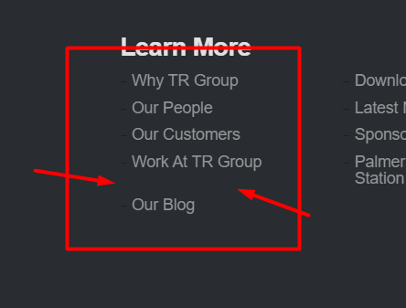

|  |  |
| --- | --- |
| **Browser** | Chrome Version 89.0.4389.114 (64-bit) |
| **Device & Operating System** | Lenovo ThinkPad W541 Windows 10 |
| **Suggestion** | **Specify he share button on the vehicle detail page, put more optional buttons of social networks** |
| **Steps to reproduce** | 1. Open Chrome browser 2. Navigate to <https://www.trgroup.co.nz> 3. Navigate to Vehicle page 4. Click on the first vehicle image 5. Change the share button. Put optional buttons for several social networks |

Screenshot:

